What Drives NBA Player Salaries? An Empirical Analysis of Performance, Availability, and Awards

1. Introduction
As I wrote in my proposal, if I could design my dream job, being a general manager of an NBA team would be near the top of the list. I follow the league closely, and I’m fascinated by how front offices decide what a player is “worth.” NBA contracts are complicated; max salaries, rookie scale deals, supermax extensions, player options, injuries, and the salary cap all interact in ways that don’t always line up with simple box-score stats.
For this econometric project, I wanted to feel what it’s like to be a general manager and discover what they value. I wanted to know which observable factors actually show up in player salaries, and how big their effects are. In other words, when we look across NBA players in a single season, what seems to matter most: advanced performance metrics, experience and age, availability (games played), or high-profile accolades like All-Star and All-NBA selections?
Originally, I planned a more complicated model that also included market size, experience in years, and metropolitan population data from FRED. As I started working in Stata, it quickly became clear that trying to merge multiple external datasets and track players across markets would add a lot of data management complexity without necessarily improving the basic story. Given the scope of the class and the tools we’ve used, I decided to focus on a clean cross-sectional model with variables taken directly from NBA salary and box-score/advanced stats databases.
As I moved deeper into the project, I realized that estimating NBA salaries is far more complicated than it first appears. In class, I even brought up potential changes to my dataset based on the timing of contracts. This itself creates a major econometric challenge though as players are often paid based on past performance, not necessarily the season we observe in the data. A breakout season in 2022–23 may not show up in salary until a contract extension kicks in a year or two later. Conversely, a player might be underpaid relative to his production because he is still on a rookie-scale deal or mid-level exception, or overpaid because he signed a long-term contract before declining. The league’s contract landscape includes restricted vs. unrestricted free agency, Bird rights, supermax eligibility, rookie extensions, two-way contracts, option years, and cap smoothing rules which means salaries move in discrete jumps, not gradual adjustments. Once I added the additional layer of trying to match each player to the market size of the metropolitan statistical area (MSA) using FRED population data, I realized I was creating a dataset that was much more complex than what we typically handle in this course. Tracking team changes, midseason trades, partial seasons, and linking each player to the correct MSA population for that year quickly became messy and time-consuming, especially for players appearing on multiple teams in one season. After reflecting on these factors and thinking about what was more aligned and realistic with the goals of the course I decided to focus on a clear cross-sectional dataset using variables already available directly from Basketball-Reference and Spotrac, rather than trying to force a panel-style structure with multiple external sources. This still allows me to explore the main economic question without taking on modeling choices that would be unrealistic for the scope of this assignment.
My econometric question is: How do performance (BPM), age, availability (games played), and awards (All-Star and All-NBA selections) relate to NBA player salaries in the 2022–23 season?
The rest of the paper is organized as follows. Section 2 describes the dataset and the steps I took to clean and transform the variables in Stata. Section 3 lays out the econometric model and the expected signs of the coefficients, and discusses the main scatterplot of log salary versus BPM. Section 4 presents the empirical results, including summary statistics, correlations, OLS regression estimates, and tests for heteroskedasticity with robust standard errors. Section 5 concludes and discusses limitations, especially the difficulty of claiming causality in this setting.

2. Description of the Dataset

2.1 Data sources
I constructed my dataset by combining widely publicly available NBA data:
Salaries: 2022–23 player salary information from Spotrac’s NBA contract data (annual salary by player).
Performance statistics and awards: Box score and advanced statistics from Basketball-Reference for the 2022–23 regular season, including Box Plus/Minus (BPM), games played (GP), age, and whether players made th4e All-Star Game or an All-NBA team.
I exported these into a single Excel file with one observation per player-season. After cleaning, I ended up with 467 players, which satisfies the requirement of at least 30 observations.

2.2 Cleaning and variable construction in Stata
Importing the Excel file into Stata was more annoying than I expected. Instead of reading the original column names, Stata labeled the columns generically as A, B, C, …, AZ. The first row still held the text labels (“Player Name”, “Salary”, etc.), so the first thing I had to do was:
Drop the index and header row. I dropped column A (a numbering column) and then dropped the row where column B contained the text "Player Name".
Rename the variables. Based on the Excel layout, I renamed B to playername, C to salary, E to age, F to team, G to gp (games played), and AY to bpm (Box Plus/Minus)
Keep only the relevant variables. To stay within the project scope, I kept playername, salary, age, team, gp, and bpm. In the grander dataset I downloaded from the sports websites there were around 50 predictors that I did not want to include
Convert strings to numeric. Some of these were stored as strings, so I used destring to convert them to numeric, ignoring commas and other formatting characters.
Log transformation. Salaries are heavily skewed, with a few superstars earning tens of millions and many players at the minimum. To stabilize variance and interpret coefficients as percentage changes, I created
$$\text{ln_salary}=ln⁡(\text{salary}).$$
Next, I manually created award dummy variables:
allstar = 1 if the player was selected to the 2022–23 All-Star Game, 0 otherwise.
allnba = 1 if the player made any All-NBA team (First, Second, or Third) in 2022–23, 0 otherwise.
This required going down the All-Star and All-NBA lists and matching exact name strings in Stata. That process was tedious but straightforward.

2.3 Summary statistics and potential issues
Table 1 (Summary Statistics) reports the mean, standard deviation, minimum, and maximum for the variables used in the regression:
Table 1
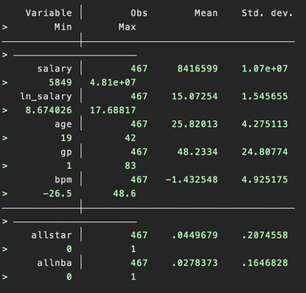
Salary: The average salary is about $8.4 million, with a standard deviation of $10.7 million. The minimum salary in the dataset is $5,849 (likely a two-way or 10-day contract), and the maximum is $48.1 million for the highest-paid superstar.
Log salary: The mean of ln(salary) is 15.07 with a standard deviation of 1.55.
Age: Average age is 25.8 years, ranging from 19 to 42.
Games played (GP): Players appear in an average of 48.2 games, with a range from 1 to 83 (for players traded mid-season or counted across teams).
BPM: The average BPM is –1.43, with a wide range from –26.5 to 48.6. The extreme values suggest a few outliers, but they are part of real NBA data, where end-of-bench players can have very negative BPM, and some small-sample players can post extremely high BPMs.
All-Star and All-NBA dummies: About 4.5% of players are All-Stars and 2.8% are All-NBA, consistent with the fact that these are very selective honors.
The main issues in the dataset are:
Outliers in BPM and salary, which can influence OLS but also reflect real differences in NBA talent.
Contract timing: Salary in 2022–23 often reflects past performance and previous years, not just the 2022–23 stats I use.
Cross-sectional nature: I only used one season, so I cannot track how changes in performance over time affect changes in salary.
Despite these limitations, the dataset is well-suited to illustrating the econometric tools used in class.

3. Econometric Model and Hypotheses

3.1 Model specification
The main model I estimate is a cross-sectional multiple regression:
$$ln⁡({\text{salary}}_{i})=β_{0}+β_{1}{\text{BPM}}_{i}+β_{2}{\text{Age}}_{i}+β_{3}{\text{GP}}_{i}+β_{4}{\text{AllStar}}_{i}+β_{5}{\text{AllNBA}}_{i}+u_{i}$$
where player $i$is the unit of observation.
Dependent variable is $ln⁡({\text{salary}}_{i})$: natural log of annual salary in dollars.
The key independent variable is ${\text{BPM}}_{i}$: Box Plus/Minus, measuring overall performance per 100 possessions relative to an average player.
Control variables: ${\text{Age}}_{i}$ (age in years), ${\text{GP}}_{i}$ (games played in the 2022–23 regular season), ${\text{AllStar}}_{i}$ (dummy equal to 1 if the player was an All-Star), and ${\text{AllNBA}}_{i}$ (dummy equal to 1 if the player made an All-NBA team).
Originally, I planned to include experience, market size, and ln(MSA population), but merging those external datasets into Stata and aligning them by team and season would have pushed the project beyond the level we’ve covered in class. Instead, I treat age as a rough proxy for experience, and I focus on individual performance and awards rather than team markets.

3.2 Expected signs
Based on economic intuition and NBA knowledge, I expected:
$β_{1}>0$: Better BPM (stronger overall performance) should increase salary.
$β_{2}>0$up to a point: Older players tend to earn more at least through their late 20s and early 30s.
$β_{3}>0$: More games played signal durability and reliability.
$β_{4}>0$: All-Star players are high-profile and usually on big contracts.
$β_{5}>0$: All-NBA selections often trigger contract bonuses or supermax eligibility, so these players should earn more.

3.3 Scatter plot of log salary and BPM

Figure 1

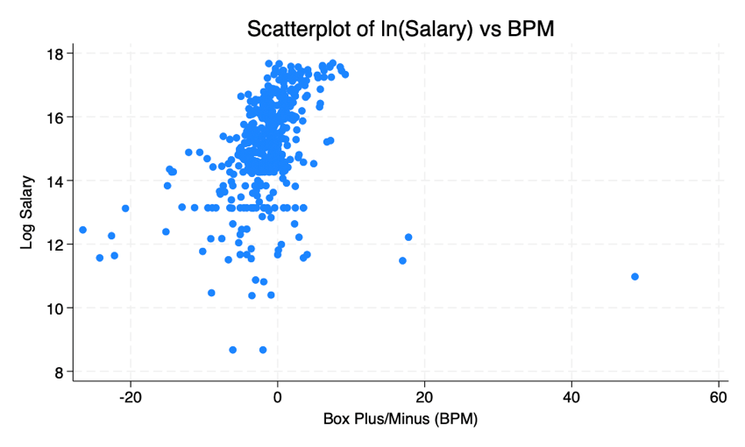
Figure 1 shows a scatterplot of ln(salary) against BPM. The cloud of points is noisy, but there is a visible upward pattern: players with very negative BPMs tend to earn lower salaries, while most high-salary players cluster around mildly positive BPMs. There are a few extreme observations—players with huge BPM but modest salaries (likely young or on small contracts) and some expensive veterans with only average BPM. The scatterplot suggests a positive but imperfect relationship, justifying a multivariate regression where we also control for other factors.

4. Empirical Results

4.1 Correlations
A pairwise correlation matrix between ln(salary), BPM, age, games played, All-Star, and All-NBA provides a first look at the relationships:
Table 2
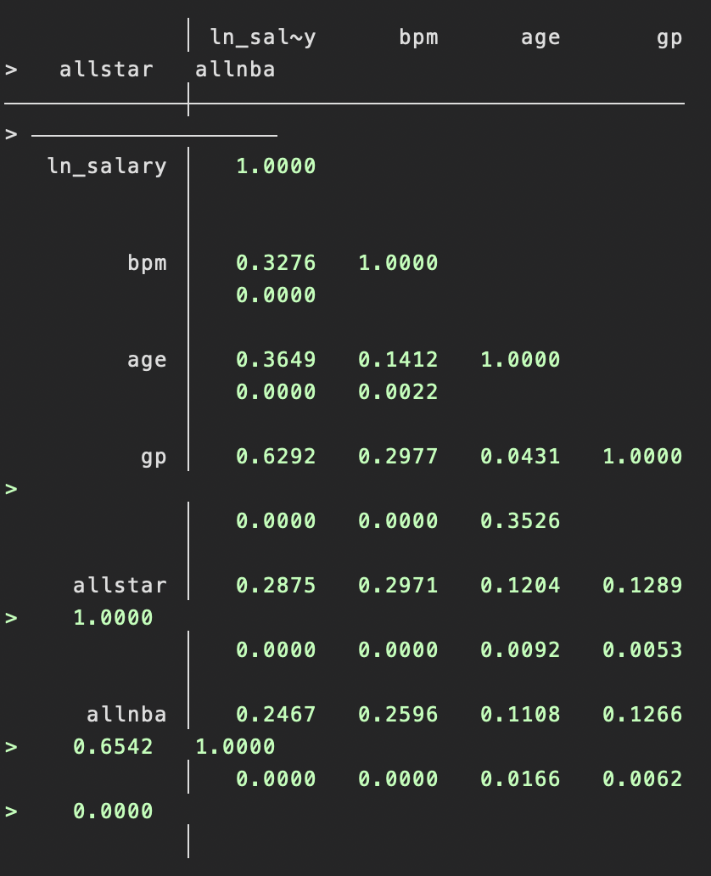
ln(salary) correlates positively with BPM (0.33), age (0.36), and especially games played (0.63), all significant at the 1% level. ln(salary) also has positive correlations with All-Star (0.29) and All-NBA (0.25). All-Star and All-NBA are highly correlated with each other (0.65), which makes sense because All-NBA players are typically All-Stars as well.
These correlations confirm that higher salaries tend to be associated with better performance, more experience, more games played, and higher-profile awards, but they do not control for overlap among variables. That calls for multiple regression.

4.2 OLS regression results
Table 3 (Regression Results) reports the coefficients from OLS with robust standard errors:
Table 3
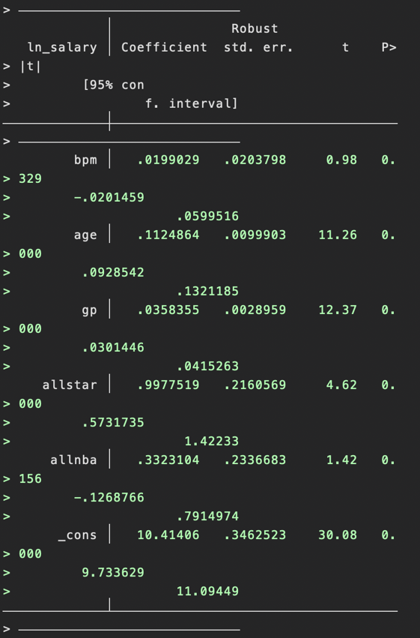
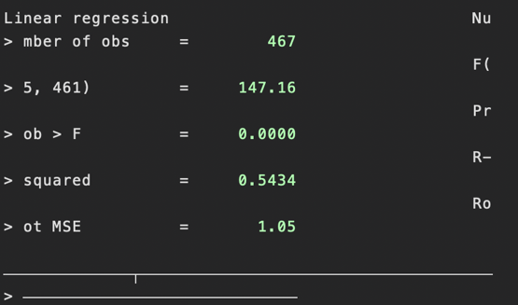
$$ln⁡({\text{salary}}_{i})=10.41+0.0199 {\text{BPM}}_{i}+0.1125 {\text{Age}}_{i}+0.0358 {\text{GP}}_{i}+0.998 {\text{AllStar}}_{i}+0.332 {\text{AllNBA}}_{i}+u_{i},$$
with 467 observations and an $R^{2}$of 0.54.
Using robust standard errors, the key findings are:
BPM: The coefficient is 0.0199 with a robust p-value of 0.329. While the sign is positive, BPM is not statistically significant once controls are included. Economically, it suggests that a one-point increase in BPM is associated with roughly a 2% increase in salary ($e^{0.0199}-1≈2.0\%$), but the estimate is too noisy to be confident in that effect.
Age: The coefficient on age is 0.1125 and highly significant (p < 0.001). Interpreted in percentage terms, an additional year of age is associated with about a 12% higher salary, holding other variables constant. This reflects the fact that older players are often past their rookie deals and have had time to negotiate larger contracts.
Games played (GP): The coefficient on games played is 0.0358, again highly significant (p < 0.001). A 10-game increase in games played is associated with roughly $e^{0.358}-1≈43\%$higher salary, which captures how important durability and availability are in determining contract value.
All-Star: The All-Star dummy has a coefficient of 0.998 with a robust p-value < 0.001. Being an All-Star is associated with approximately $e^{0.998}-1≈171\%$higher salary relative to comparable non–All-Star players, holding BPM, age, and games played constant. This highlights how strongly star status and visibility are rewarded in the market.
All-NBA: The coefficient on All-NBA is positive (0.332), consistent with expectations, but not statistically significant at conventional levels (p ≈ 0.16) with robust errors. One reason is that there are very few All-NBA players in the sample, and many of them are already captured as All-Stars and high-earning veterans, so the incremental effect is hard to distinguish statistically.
Overall, the model explains about 54% of the variation in log salaries, which is quite high for cross-sectional data and suggests that these observable variables capture a substantial portion of how the NBA labor market prices players.

4.3 Heteroskedasticity and robust standard errors
I tested for heteroskedasticity using the Breusch–Pagan/Cook–Weisberg test and White’s test. They can be seen here:
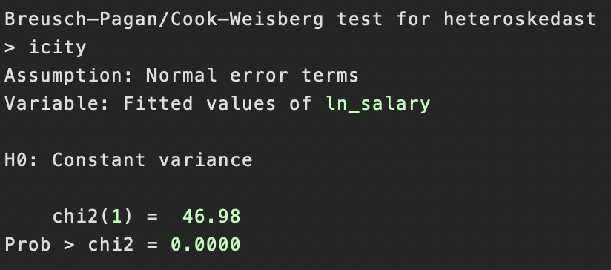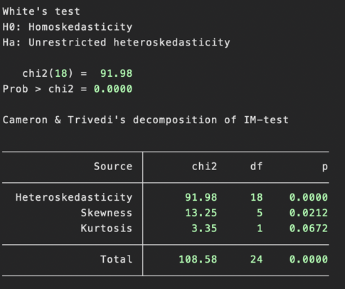
The Breusch–Pagan test yields χ²(1) = 46.98, p < 0.0001. White’s test yields χ²(18) = 91.98, p < 0.0001.
Both tests strongly reject the null hypothesis of homoskedastic errors, which is not surprising in this context: salary dispersion tends to be much larger among high-level players than among minimum-salary players. In other words, the variance of the error term increases with the level of predicted salary.
Because of this, I re-estimated the model using robust standard errors. The coefficient estimates themselves barely changed, but the standard errors on BPM and All-NBA increased, confirming that these variables are not statistically significant once we correct for heteroskedasticity. Age, games played, and All-Star status remain highly significant and are the main drivers of salary in this specification.

4.4 Interpreting the predicted impact
Putting the coefficients together, the model suggests that:
Salary rises steeply with age and games played, reflecting experience and availability. All-Star selection is one of the strongest signals the market responds to, with All-Stars earning nearly triple the salary of otherwise similar players. BPM, a detailed advanced performance metric, does not show up as significant once these other factors are included. This probably reflects institutional features of the NBA labor market such as the fact that many young high-BPM players are stuck on cheap rookie-scale contracts. Many veteran stars are locked into large contracts even if their BPM has declined. Agents and teams also may care more about status markers (All-Star) and basic counting stats than about advanced metrics like BPM.
In short, the results suggest that experience, health, and visible recognition go further in explaining salary than advanced analytics alone.

5. Conclusion and Limitations
This project set out to answer how performance, experience, availability, and awards relate to NBA player salaries in the 2022–23 season. Using a cross-sectional regression of log salary on BPM, age, games played, and dummies for All-Star and All-NBA status, I found that age, games played, and All-Star status are strong, statistically significant predictors of salary. BPM and All-NBA status have positive but statistically insignificant effects once these controls are included. The model explains over half of the variation in salaries, suggesting that these observable characteristics capture a large part of how teams value players.
At the same time, there are important limitations:
Causality: The regression is purely associational. Contracts are often based on past performance and expectations about the future, and reverse causality is possible (high-salary players may get more minutes and opportunities).
Contract structure: NBA salaries are determined in a heavily regulated environment with max contracts, rookie scales, and supermax rules, none of which are modeled here. These institutions probably explain why BPM does not show up as strongly as expected—some high-performing players are literally not allowed to earn more because of contract rules.
Omitted variables: I do not control for position, team, years of experience, injuries, or other advanced metrics. These omitted factors may be in the error term and could bias some coefficients.
Single-season data: Using only 2022–23 prevents me from studying how changes in performance translate into changes in salary over time.
Despite these limitations, the project helped me practice the full econometric: obtaining data, cleaning it in Stata, transforming variables, visualizing relationships, running multiple regression, diagnosing heteroskedasticity, and using robust standard errors. On a more personal level, it gave me a more concrete sense of how front offices might weigh different pieces of information. The results suggest that in the NBA labor market, being healthy, experienced, and recognized as a star may matter more for pay than purely analytical performance metrics like BPM, which an insight I’ll carry with me if I ever do end up in a general manager’s chair. This also has implications on what teams and players might choose to prioritize going forward.

6. References
Basketball-Reference. 2022–23 NBA Player Statistics. Retrieved from: https://www.basketball-reference.com
Spotrac. NBA Player Contracts and Salaries, 2022–23 Season. Retrieved from: https://www.spotrac.com

